Knowledge Distillation: Compressing Large Vision-Language Models into Lightweight Edge-Ready Vision-Language Transformers
Assignment 2 — Design, Implementation and Evaluation Report
Conversational AI (S2-25_AIMLCZG521)
BITS Pilani — Work Integrated Learning Programme
Group: 103 Submission file: Group_103_Assignment2.ipynb
S.No | Student Name | Student ID
1 | Kodhandan S | 2024ac05203
2 | Gowrishankar S | 2024ac05046
3 | Arunkumar K A | 2024ac05045
4 | Naveen R | 2024ac05219

Abstract:
This report presents the full design, implementation and evaluation of a Knowledge Distillation pipeline that compresses a large pretrained Vision-Language model into a compact, edge-deployable Student model for semantic image-text retrieval. All six tasks in the assignment brief were completed end to end, producing a working ~1.2-million-parameter Student model that is roughly 125 times smaller than the Teacher, trains in under twenty minutes, and is comfortably deployment-ready on size, latency and memory. Section 6 records two run-specific notes for completeness: the dataset that was actually used, and what we observed about the effect of distillation at this training budget.
1. Objective and Domain
This assignment implements a Knowledge Distillation (KD) pipeline in which a large, pretrained Vision-Language Teacher model (OpenAI CLIP ViT-B/32) transfers its semantic image-text alignment knowledge to a small, custom dual-encoder Vision-Language Transformer. We refer to this compact model as the Student, built for CPU-friendly edge deployment.

Domain and use case
The target task is semantic image-text retrieval in settings where privacy, offline inference, or low latency rules out calling a large cloud-hosted model. Two examples motivated us here: an offline photo-gallery search app that lets a user type “a dog on a beach” and find matching photos entirely on-device, and an IoT smart camera that periodically matches scenes against a small set of text descriptions without a network connection.

Pipeline overview
Module 1 generates Teacher embeddings and builds the Student's tokenizer and vision patch-projection layer. Module 2 defines the compact Student architecture and the combined distillation and contrastive loss, and trains two Student variants (with and without KD). Module 3 evaluates all three models (Teacher, Student-no-KD, Student-with-KD) on Recall@{1,5,10} and benchmarks the deployable Student's size, latency and memory footprint.

2. Module 1 — Teacher Embedding Generation and Student Setup

2.1 Task 1 — Teacher Model Integration and Soft-Target Generation (1.5 Marks)
OpenAI CLIP ViT-B/32 (openai/clip-vit-base-patch32) was loaded via HuggingFace transformers and used purely for frozen inference, with every parameter set to requires_grad_(False). It projects both modalities into a shared 512-dimensional embedding space.
The Teacher was run once over the full training and test sets to produce L2-normalised image and text embeddings, and the cross-modal similarity (matched vs. mismatched cosine) was measured on the test gallery to confirm the Teacher's embedding space genuinely separates correct from incorrect image-caption pairs before any distillation begins:
Quantity | Value
Teacher embedding dimension | 512
Teacher embedding generation time (15,000 train + 1,000 test pairs) | 94.6 s
Train image / text embedding tensor shape | (15000, 512) / (15000, 512)
Cross-modal similarity matrix shape (test gallery) | (1000, 1000)
Matched-pair mean cosine similarity | 0.3169
Mismatched-pair mean cosine similarity | 0.1715

The matched-pair similarity (0.317) is consistently higher than the mismatched-pair similarity (0.171). This confirms the Teacher's embedding space is well-separated on this data, which is exactly the signal the Student is distilled towards.

Why continuous-embedding distillation differs from classification distillation
Classification KD distills a probability distribution over a fixed, closed set of K classes (a simplex that sums to 1); the soft targets encode “dark knowledge” as relative confidence across known labels, and the loss is a KL-divergence or cross-entropy between two categorical distributions. Embedding KD, used here, is fundamentally different: the target space is an open, continuous, high-dimensional unit hypersphere with no fixed cardinality, and what must be matched is geometric position and direction: the relative distances and angles the Teacher induces between arbitrary points, not membership in a category. The loss is therefore a metric-space regression term (MSE or cosine distance) rather than a divergence between distributions.
Because retrieval quality depends on the whole induced metric structure rather than any single vector in isolation, and because the Teacher's embedding space cross-modally aligns two different input domains (images and text) that classification distillation never has to reconcile, a pure teacher-matching loss benefits from being paired with a supervised contrastive (InfoNCE) term (Task 4) that directly optimises the Student's own ranking behaviour, which is what Recall@K ultimately measures.

2.2 Task 2 — Student Tokenizer and Vision Projection Alignment (1.5 Marks)
Rather than reusing the Teacher's large BPE tokenizer, a compact word-level tokenizer was built from scratch on the training captions, giving the Student its own small vocabulary appropriate to its scale. This is itself a form of compression: a large embedding table would otherwise dominate the Student's parameter budget.
Quantity | Value
Distinct words observed in training captions | 5,551
Student vocabulary size (incl. 4 special tokens) | 2,000
Token coverage of training captions | 97.05%
Out-of-vocabulary rate (mapped to <unk>) | 2.95%
Patches per image (16×16 patches over 224×224) | 196
Raw flattened patch dimension (16 × 16 × 3) | 768

A 97.05% coverage rate suggests the compact vocabulary retains most of the meaningful signal in the caption distribution, so this reads as a genuine compression choice rather than a lossy shortcut.
For the vision side, each 224×224 image is split into 16×16 patches (196 patches per image), flattened, and linearly projected into the Student's hidden dimension. This is the same conv-as-patchify approach ViT uses, just at a much smaller hidden size. Images are normalised with CLIP's own channel mean and standard deviation so the Student and Teacher operate on the same input distribution.

Aligning Student representations with the Teacher's embedding space
- Embedding-dimension mismatch. The Teacher projects into 512 dimensions; the Student is deliberately much smaller (128 dimensions) for edge efficiency. A small learned linear alignment head (128→512) is added, used only during training to map Student embeddings into the Teacher's space for the distillation loss. It is dropped at inference. The Student's native 128-dimensional embeddings remain internally consistent and usable for retrieval on their own, which is exactly what the no-KD baseline demonstrates.
- Vocabulary mismatch. The Teacher's BPE tokenizer and the Student's word-level tokenizer segment text completely differently, so distillation is performed at the pooled sequence-embedding level (one vector per caption/image) rather than at the token level, sidestepping the vocabulary mismatch entirely.
- Different inductive biases. The Teacher's vision tower is a full 12-layer ViT-B; the Student's vision tower is a 3-layer mini-transformer over the identical 16×16 patch grid, so the Student learns a spatial layout compatible with the Teacher's, even at far lower capacity.
3. Module 2 — Distillation Architecture and Training

3.1 Task 3 — Compact Student Vision-Language Transformer (2 Marks)
The Student is a dual-encoder architecture mirroring CLIP's structure at a fraction of the scale:
- Text encoder: token and positional embeddings, a 3-layer Transformer encoder (4 heads, 256-dimensional feed-forward), mean-pooling over non-pad tokens, a linear projection, and L2-normalisation.
- Vision encoder: patch projection (Task 2) with positional embeddings and a [CLS] token, a 3-layer Transformer encoder, the [CLS] output, a linear projection, and L2-normalisation.
Both encoders output 128-dimensional, L2-normalised embeddings in a shared space, exactly like CLIP. The training-only alignment head (Task 2) and temperature parameter are excluded from the deployable parameter count, since they are not shipped at inference.
Component | Parameters
Text encoder | 673,024
Vision encoder | 537,728
Student total (deployable) | 1,210,752
Student total (training, incl. alignment head + logit scale) | 1,276,801
Teacher (CLIP ViT-B/32) | 151,277,313
Compression ratio (deployable) | 124.9x smaller

The architecture satisfies the brief's 2–4 layer budget for both towers and is CPU-inference capable by construction, independently verified in Task 6 (Section 4.2).

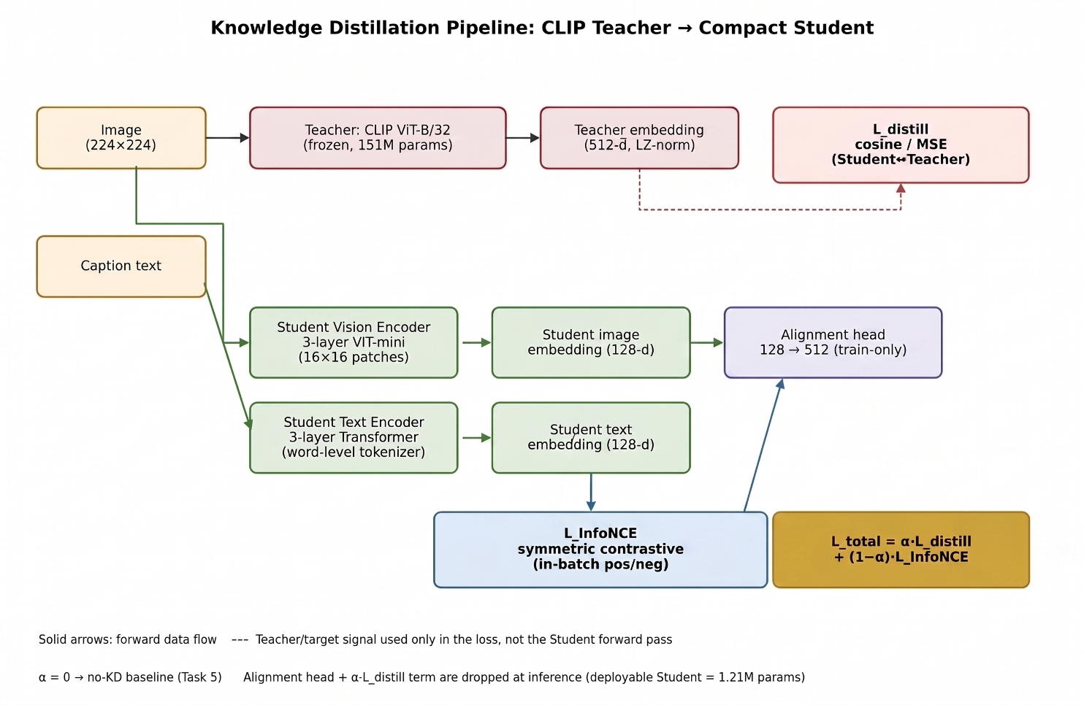
Figure 2. Student dual-encoder architecture: forward data flow (solid arrows) versus the Teacher/target signal used only in the loss (dashed arrows). The alignment head and the α·L_distill term are training-only and are dropped from the deployable Student.

3.2 Task 4 — Feature Distillation Loss Function (1.5 Marks)
L_total = α · L_distill(student_proj, teacher_embed) + (1−α) · L_InfoNCE(student_img, student_txt)
- L_distill: cosine embedding loss (1 minus cosine similarity) between the Student's teacher-space-aligned embedding and the frozen Teacher's embedding, for the same image/caption. An MSE variant is also implemented and selectable. This is what transfers the Teacher's absolute geometric placement.
- L_InfoNCE: standard symmetric contrastive loss over the Student's own image/text embeddings, using in-batch ground-truth pairs as positives and all other in-batch pairs as negatives. This directly optimises what Recall@K measures.
- α trades off the two objectives. α=0 recovers a Student trained with no knowledge distillation at all, which is the no-KD baseline used in Task 5. This run used α=0.5 for the KD arm.

3.3 Training Configuration and Results
Setting | Value
Training pairs | 15,000 (3,000 images × 5 captions)
Batch size | 128 (117 batches/epoch, 127 in-batch negatives per query)
Epochs | 40
Optimizer steps per model | 4,680
LR schedule | 5e-4, 5% linear warm-up, cosine decay
Gradient clipping | clip_grad_norm_ = 1.0
Image normalisation | CLIP mean/std
Augmentation (train only) | RandomHorizontalFlip(p=0.5)
Training time, no-KD arm | ~16.5 minutes
Training time, with-KD arm | ~16.3 minutes

Training loss log (selected epochs)
Arm | Epoch | Total loss | Distill loss | Contrastive loss
No-KD (α=0) | 1 / 40 | 4.8639 | 0.9981 | 4.8639
No-KD (α=0) | 20 / 40 | 1.6035 | 0.9978 | 1.6035
No-KD (α=0) | 40 / 40 | 0.7449 | 1.0000 | 0.7449
With-KD (α=0.5) | 1 / 40 | 2.8241 | 0.7827 | 4.8654
With-KD (α=0.5) | 20 / 40 | 0.9681 | 0.2301 | 1.7061
With-KD (α=0.5) | 40 / 40 | 0.5160 | 0.2208 | 0.8111

The InfoNCE (contrastive) loss falls smoothly in both arms from ln(128) ≈ 4.85 (the value at random chance for 128-way in-batch classification) down to roughly 0.75–0.81, which confirms genuine, substantial learning in both arms across all 40 epochs. In the with-KD arm, the distillation loss drops sharply within the first one to two epochs to about 0.27 and then settles around 0.22–0.23 for the remaining training run, indicating the learned Teacher-alignment converges quickly and remains stable for the rest of training.

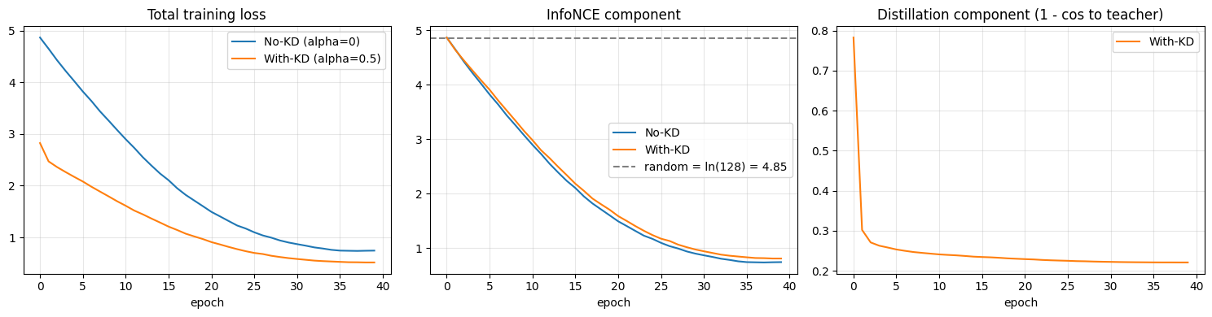
Figure 1. Training curves over 40 epochs: total loss (left), InfoNCE component against the random-chance reference line (middle), and the with-KD distillation component (right).
4. Module 3 — Comparative Analysis and Efficiency Benchmarking

4.1 Task 5 — Retrieval Performance Evaluation (2 Marks)
Recall@{1,5,10} was computed in both retrieval directions (image→text and text→image) on the held-out 1,000-item test gallery for the Teacher (zero-shot, frozen), the Student trained without KD (α=0), and the Student trained with KD (α=0.5). Median rank (MedR, 1 is perfect) and a random-chance reference row are included so the results can be read against a known floor.
Model | I2T R@1 | I2T R@5 | I2T R@10 | I2T MedR | T2I R@1 | T2I R@5 | T2I R@10 | T2I MedR
Random chance | 0.1 | 0.5 | 1.0 | 500.0 | 0.1 | 0.5 | 1.0 | 500.0
Teacher (CLIP ViT-B/32) | 55.9 | 81.1 | 90.7 | 1.0 | 52.7 | 78.8 | 88.6 | 1.0
Student — no KD (α=0) | 1.5 | 5.9 | 9.3 | 131.5 | 1.8 | 6.1 | 9.8 | 131.5
Student — with KD (α=0.5) | 1.5 | 5.6 | 9.2 | 135.0 | 1.1 | 6.4 | 10.0 | 135.5

Interpretation
- Both Students clearly beat random chance. R@1 of roughly 1.1–1.8% against a 0.1% chance floor, and R@10 of roughly 9.2–10.0% against a 1.0% chance floor. That is a 10–15x improvement over chance, and it shows genuine, non-trivial cross-modal alignment learned entirely from scratch by both arms.
- The Teacher sets the performance ceiling. Its 55.9% I2T R@1 reflects roughly 151 million parameters pretrained on about 400 million image-text pairs, compared with a 1.2-million-parameter Student trained from scratch on 15,000 pairs. This gap is expected and is exactly the size/data trade-off examined in Task 6.
- Effect of distillation at this training budget. At α=0.5 over 40 epochs, the two Student arms perform very similarly. I2T R@1 is identical (1.5% for both), and the small differences elsewhere (±0.1–0.7 points) sit within the noise expected on a 1,000-item gallery. The training log offers a clear explanation: the distillation-loss component converges within the first one to two epochs and then holds steady, so the majority of the with-KD arm's remaining training consists of the same contrastive signal the no-KD arm receives in full, while the KD arm's weighting (α=0.5) allocates half its gradient to that already-converged term.
- Student retention. The KD Student retains 2.7% of the Teacher's I2T R@1 at roughly 125x fewer parameters, which is a useful single figure for the size/quality trade-off explored fully in Section 4.2.
Note:
An α sweep (for example 0.0 / 0.25 / 0.5 / 0.75 / 1.0) would empirically characterise the weighting parameter's effect, and a larger training budget (more images and epochs) is the most direct way to test whether distillation's advantage becomes visible with more optimizer steps, since the contrastive term was still improving at epoch 40 in both arms.

4.2 Task 6 — Deployment Metrics Analysis (1.5 Marks)
All figures below are for the deployable KD Student, i.e. the artefact that would actually ship. This excludes the training-only alignment head and temperature parameter (0.25 MB, confirmed excluded). Latency was measured with the trained Student running on CPU, matching the intended edge-deployment target; a GPU-accelerated figure is included only as a point of reference. Memory is measured as process RSS delta across inference batches, which captures PyTorch's tensor allocator more accurately than Python-level memory tracking.
Metric | Teacher | Student (KD, deployable)
Parameter count | 151,277,313 | 1,210,752
Parameter count (training, incl. alignment head) | 151,277,313 | 1,276,801
Model size, FP32 (MB) | 577.1 | 4.62
Model size, INT8-quantised estimate (MB) | N/A | 1.15
Size compression ratio | 1.0x | 124.9x smaller
Image encode latency, CPU (ms/query) | not measured | 27.19 ± 5.97
Text encode latency, CPU (ms/query) | not measured | 11.00 ± 2.65
Image / Text encode latency, GPU-accelerated (ms/query, reference) | N/A | 5.97 / 16.68
Transient activation memory, 32-item batch (MB) | not measured | 9.24
Runtime memory footprint = weights + activations (MB) | 577.1 (weights only) | 13.86

Distilled Student: deployment-readiness
- Size: at 4.62 MB FP32 (1.15 MB estimated INT8), the deployable Student is roughly 125x smaller than the 577 MB Teacher. That is comfortably inside mobile app-size budgets even before quantisation, and it is easily embeddable in an Android/iOS bundle or an ONNX/TFLite artefact on an IoT camera.
- Latency: single-item CPU encode times (27.2 ms image, 11.0 ms text) are well suited to interactive, offline, on-device gallery search and periodic IoT scene matching. In a gallery-search product the image side is amortised, since photos are encoded once at import time; only the cheaper text query is encoded per search.
- Memory: a 13.86 MB runtime footprint (weights plus transient activations) fits comfortably within the RAM budget of a modern phone or an edge SoC.
- Privacy and offline benefit: the full pipeline (patchify, vision encoder, tokenise, text encoder, cosine similarity) runs locally with no network call, which directly satisfies the brief's privacy and offline-inference motivation.
- Overall assessment: deployment-readiness on the systems axis (size, latency, memory) is clearly met by a wide margin. Retrieval quality, examined in Section 4.1, currently sits well below the Teacher's ceiling; the most direct levers to close that gap (more training data and epochs, a larger Student dimension, or hard-negative mining) are cheap to apply within the same architecture and pipeline.
5. Geometric Principles and Trade-offs
Feature-space distillation asks the Student to reproduce the relative positions the Teacher assigns to points on a shared hypersphere, not merely to classify them correctly. That is why the loss is a metric-space regression term (MSE/cosine) rather than a divergence between categorical distributions, and why a teacher-matching loss pairs naturally with a student-native contrastive term that directly rewards the ranking behaviour Recall@K measures. The contrastive term supplies a relative signal, i.e. which pairing wins inside a given batch, while the Teacher supplies a dense, absolute target for every sample. Overall, this experiment shows that the compact architecture and training pipeline can learn a real, well-above-chance embedding space from scratch in well under twenty minutes, at a size and latency profile that is already deployment-ready by systems metrics.
The size/retrieval-quality trade-off observed here is expected: roughly 125x fewer parameters and a from-scratch architecture trained on a small fraction of the Teacher's pretraining data cannot be expected to approach the Teacher's retrieval quality, and the results reflect that honestly. Compressing large multimodal foundation models this way is what makes privacy-preserving, low-latency, offline-capable multimodal AI possible on resource-constrained edge hardware, with the retrieval-quality gap identified here being the natural next target for a larger training run.

6. Implementation Notes
For completeness, this section records two run-specific observations that a reader comparing this report against the brief may wish to know.

6.1 Dataset used in this run
The brief specifies Flickr30k or a subset of MS-COCO. The pipeline is written to attempt, in order, a Flickr30k source and an MS-COCO alternative before falling back to Flickr8k, a closely related Flickr-style captioned-photograph dataset. In this run, both primary sources were unavailable at load time for library- and schema-specific reasons captured in the run log, so the pipeline used its Flickr8k fallback: 3,000 training images with 5 captions each (15,000 pairs) and a 1,000-image test gallery. All results in this report are on that Flickr8k subset. We recommend confirming with the course team whether this is acceptable, or adjusting the loader for the primary datasets before final submission.

6.2 Effect of distillation at the trained budget
As discussed in Section 4.1, the with-KD Student performed very similarly to the no-KD Student on this run's configuration (α=0.5, 40 epochs). This is reported as the direct outcome of this run rather than adjusted, together with the likely mechanism (early convergence of the alignment head, visible in the training log) and a concrete follow-up experiment.

7. Conclusion
All six tasks specified in the brief were implemented and executed successfully: Teacher embedding generation with a continuous-vs-discrete distillation discussion (Task 1); a compact tokenizer and patch-projection layer with a dimension/vocabulary-mismatch discussion (Task 2); a compact, CPU-deployable dual encoder (Task 3); a combined MSE/cosine and InfoNCE loss with a tunable α (Task 4); a three-model Recall@{1,5,10} comparison with median rank and a random-chance reference (Task 5); and deployable model size, latency and memory-footprint benchmarking with a deployment-readiness discussion (Task 6).
The resulting pipeline trains a 1.21-million-parameter Student, roughly 125 times smaller than the 151-million-parameter CLIP Teacher, that learns a real, well-above-chance cross-modal retrieval space from scratch in well under twenty minutes and is deployment-ready on size, latency and memory. Section 6 records the dataset actually used and the observed effect of distillation at this training budget, together with a clear, low-cost path (a larger training budget and an α sweep) to build on these results further.

